Name_____________________________ RS English/Halvorson

**Topic Research Preparation:**  Using the small amount of research you conducted while selecting potential cause/effect essay topics, fill in the boxes as best as you can.  Understand that some categories may remain empty, depending on your topic.  Understand that with some topics there will be more causes to address and with other topics there will be more effects.   This information will help you narrow your focus for your research.  Remember, if you write a causes essay information about the effects will appear in the conclusion. If you write an effect essay, causes will appear in the introductory paragraph. This is why you will keep track of both.

**Objective**: After this brainstorm you will have a direction and key words to aid in your research process.

I am researching coral reef damage

C:\Users\Jason\AppData\Local\Microsoft\Windows\INetCache\Content.MSO\1FBDCC43.tmp

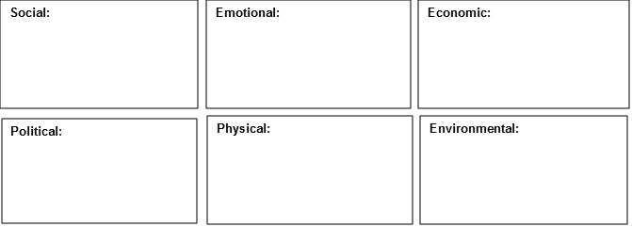

Sunscreen damaging to reef

None

Relaxed environmental laws

Coral trade/selling

Damaged ozone layer

Run-off from farming/mining

Tourism – damage

C:\Users\Jason\AppData\Local\Microsoft\Windows\INetCache\Content.MSO\EB16F43F.tmp

Page Break

None

Impact on other oceanic life

Loss of tourism

Loss of aquatic species

Loss of industry

Loss of aquatic species

**Reflection**:  Answer the following questions to help you reflect on your brainstorm.

1. Most of my brainstormed information ended up in the   cause      effect      category.

                (*circle one)*

2. Keeping my response to question one in mind, the three larger categories that I had the most information for were: *(circle or highlight three)*

               Social        emotional        economic      political      physical       environmental

3. My focus statement for my cause/effect essay could be:

Awareness of the social, economic, and environmental causes of coral reef damage needs to be understood in order to protect the reefs from further destruction.

 Sample focus statements:

*A careful implementation of increased minimum wage must be made in order to avoid political, economic, and emotional effects.

*Social media is a double-edged sword in our society, and it is important to understand the social, political, and emotional effects on the modern world.

*Regarding the alarming amounts of sexual assault on college campuses, there are complicated political, educational, and social reasons for that existence.

**As you continue your research, you might find that you will replace the words “social, political, or environmental” with more specifics. Remember, this activity was to help you discover key word searches for your research.**